**ABSTRACT**

In the era of information explosion, individuals and organizations are constantly inundated with large volumes of textual data generated through emails, instant messaging applications, customer service interactions, and various online communication platforms. Manually extracting meaningful insights from such vast and unstructured conversational data is not only time-consuming but also inefficient and prone to human error. This challenge necessitates the development of automated summarization techniques that can condense long conversations into concise, coherent summaries while preserving the original intent and context of the dialogue.

This project, titled **"Text Summarizer using NLP"**, focuses on building an efficient and accurate dialogue summarization system utilizing advanced Natural Language Processing (NLP) techniques. The core objective is to automatically generate short summaries from lengthy conversations, specifically using the samsum dataset, which contains over 14,000 training samples of real-life messenger-like dialogues paired with human-written summaries. By employing transformer-based architectures, the project aims to overcome the complexities associated with understanding the context and flow of natural conversations.

For this purpose, we have implemented the **DistilBART** model, a lightweight, distilled version of Facebook AI’s BART model, known for its efficiency and high performance in text generation tasks. DistilBART, coupled with the BART tokenizer, provides the benefits of faster training times and reduced computational resource requirements, making it suitable for environments with limited hardware capabilities. The training pipeline is built using the Hugging Face Transformers library, which simplifies model training, evaluation, and deployment processes.

The evaluation of the model is carried out using the ROUGE (Recall-Oriented Understudy for Gisting Evaluation) metric, which is widely used in summarization tasks to measure the overlap between the model-generated summary and the reference summary. Our model achieves satisfactory ROUGE scores, indicating its ability to produce meaningful and accurate summaries of dialogues. Additionally, this project also explores the challenges encountered during implementation, such as device compatibility issues when initially attempting to use the more resource-intensive PEGASUS model, and the complexities involved in building efficient training pipelines.

The outcomes of this project demonstrate the potential of deploying summarization models in real-world applications such as customer support automation, meeting minute generation, and content curation. Furthermore, the project opens avenues for future enhancements, such as integrating real-time summarization capabilities, expanding to multilingual datasets, and refining the model for better contextual understanding and personalization.

In conclusion, this project successfully showcases the application of modern NLP techniques and transformer models for the task of dialogue summarization, providing a scalable solution for managing and extracting insights from extensive conversational data.

**CONTENTS**

Certificate of originality i

Certificate ii

Declaration iii

Acknowledgment iv

Abstract v

Contents vi

CHAPTER 1: Introduction

3.1. Overview 1

3.2. Project Description 4

3.3. Purpose 6

3.4. Project Scope 9

CHAPTER 2: Literature Review

2.1. Literature Review 11

2.2 problems and solution………………………………………………………………………………13

CHAPTER 3: Preliminaries

3.1. Methodologies Used 14

3.2. System Architecture 14

3.3. Technologies Used 16

3.4. Tools Used 20

CHAPTER 4: Methods & Implementation

4.1. working procedure 26

4.2. Diagram 29

4.3. Code Snippet 30

CHAPTER 5: Results & Outputs 33

CHAPTER 6: Conclusion & Future Work 35

**INTRODUCTION**

**Overview**

With the ever-increasing volume of digital information, it has become increasingly difficult to quickly access concise and relevant content. This challenge highlights the importance of developing systems capable of summarizing information in a manner similar to human summarization. Automatic text summarization, powered by Natural Language Processing (NLP), offers an effective solution by generating summaries of given documents.

Text summarization techniques are broadly classified into two main approaches: **extractive** and **abstractive** summarization.

* The extractive approach involves selecting important and distinct sentences or sections directly from the original text to create a shorter version. In this method, sentences are evaluated and selected based on various statistical and linguistic features. Extractive summarization essentially focuses on identifying and extracting a subset of sentences that effectively represent the core content of the document. This method typically relies on strategies involving sentence scoring and ranking, making use of techniques like Text Rank, PageRank, and Maximal Marginal Relevance (MMR).
* On the other hand, abstractive summarization, which is the approach adopted in our project, goes a step further by generating completely new sentences that capture the essence of the original document. Unlike extractive methods, abstractive summarization attempts to paraphrase and rewrite content, which is more challenging but yields summaries that are closer to how humans naturally summarize information.

In our project, we have implemented an abstractive text summarization model using the **DistilBART architecture** and the **BART tokenizer**, trained specifically on the **samsum dataset**. The samsum dataset is well-suited for this task as it contains dialogues that require the generation of concise summaries, making it an excellent benchmark for evaluating the performance of abstractive models.

Modern summarization systems often benefit from advancements in related fields such as text mining and information retrieval. Depending on the level of human involvement, summarization systems can be classified as:

* **Fully Automated Summarizers (FAS):** Systems that independently generate summaries without human intervention.
* **Machine-Assisted Human Summarization (MAHS):** Systems that suggest candidate sentences for human review.
* **Human-Assisted Machine Summarization (HAMS):** Systems that rely on post-processing or editing by humans.

Our system aligns with the Fully Automated Summarization approach, aiming to autonomously generate high-quality summaries from conversational texts. Summarization techniques also vary depending on the application:

* **Generic summarization:** Focused on producing an overall summary of the document.
* **Query-based summarization:** Tailored to answer specific user queries.

While extractive methods aim to select representative subsets of sentences, abstractive methods, like the one in our project, strive to understand the meaning of the entire text and generate novel sentences that encapsulate the main ideas. By leveraging pre-trained transformer models and fine-tuning them on dialogue-specific data, our approach seeks to produce human-like, coherent summaries that capture the key points of conversations effectively.

**Project Description**

The primary objective of this project is to develop an automated text summarization system that can effectively transform informal, unstructured dialogues into coherent and concise summaries. In an era where digital conversations, such as chats and instant messages, are rapidly growing, summarizing these dialogues to extract meaningful insights is becoming increasingly important. This project leverages cutting-edge Natural Language Processing (NLP) techniques and transformer-based models to address this challenge, with a focus on maintaining both high-quality output and computational efficiency.

**Dataset Selection: SAMSum Dataset**

For this project, we selected the **SAMSum dataset**, a widely recognized benchmark specifically designed for dialogue summarization tasks. The dataset is meticulously curated and consists of messenger-style conversations, each accompanied by human-written reference summaries. These characteristics make it particularly well-suited for training models to understand conversational flow and generate meaningful abstracts.

The SAMSum dataset is organized as follows:

* **Training data:** 14,732 dialogue-summary pairs
* **Test data:** 819 dialogue-summary pairs
* **Validation data:** 819 dialogue-summary pairs

The diversity and structure of the dataset enable the model to learn various conversational patterns, informal language expressions, and contextual dependencies that are typical in human dialogues. This, in turn, enhances the model's capability to generalize and produce accurate summaries for unseen data.

**Model Selection: DistilBART with BART Tokenizer**

To build the summarization system, we opted for **DistilBART**, a distilled version of the original BART (Bidirectional and Auto-Regressive Transformer) model developed by Facebook AI. DistilBART retains most of BART’s performance advantages while offering a smaller, faster, and more resource-efficient architecture. This makes it ideal for environments with limited computational capacity, without compromising too much on accuracy and fluency.

We paired DistilBART with the **BART tokenizer**, which is crucial for effective pre-processing of the conversational text. The tokenizer breaks down input dialogues into manageable tokens, handles special tokens, and ensures proper alignment between the input and output sequences. This pre-processing step is vital to maintain the syntactic and semantic integrity of the dialogues throughout the training and inference phases.

**Project Pipeline**

The workflow of our project is structured into several well-defined stages to ensure clarity, efficiency, and effectiveness:

1. **Data Loading and Preprocessing:**  
   The SAMSum dataset is first loaded and cleaned. Preprocessing involves tokenizing dialogues, handling punctuation, removing unnecessary whitespace, and preparing the data in the required format for model consumption. Special care is taken to preserve conversational markers that help the model understand the flow and structure of dialogues.
2. **Model Training:**  
   During this phase, DistilBART is fine-tuned on the training set. The model learns to map conversational inputs to their corresponding summaries by understanding sequence dependencies, speaker turns, contextual cues, and implicit meanings within the dialogue. Techniques such as teacher forcing are employed to improve convergence and output quality.
3. **Evaluation Using ROUGE Metric:**  
   The evaluation phase involves assessing the model's performance on the validation and test sets. We use the **ROUGE (Recall-Oriented Understudy for Gisting Evaluation)** metric, a standard in summarization tasks. ROUGE measures the overlap between the generated summaries and the human-written references in terms of n-gram precision, recall, and F1-score. Higher ROUGE scores indicate that the generated summaries closely match the reference summaries, both in content and structure.
4. **Summary Generation:**  
   Once the model achieves satisfactory performance, it is used to generate summaries for new, unseen dialogues. The final summaries are evaluated not only on ROUGE scores but also qualitatively, to ensure readability, coherence, and informativeness.

**Project Goals and Impact**

Through this project, our goal is to make a meaningful contribution to the growing field of dialogue summarization. By focusing on abstractive summarization using a lightweight yet powerful transformer model, we strive to strike a balance between accuracy and computational efficiency.

The practical applications of this system are extensive:

* **Customer Support Automation:** Generating quick summaries of customer interactions to help support agents respond more efficiently.
* **Meeting Minutes Generation:** Automatically summarizing lengthy team meetings or brainstorming sessions into actionable takeaways.
* **Social media and Messaging Platforms:** Summarizing long chat threads to provide users with concise overviews.

Our work also opens pathways for further enhancements, such as integrating real-time summarization capabilities, adapting the model for multilingual dialogues, or fine-tuning for domain-specific applications like legal consultations or healthcare communications.

In conclusion, this project demonstrates how advanced NLP models, coupled with thoughtfully prepared datasets and rigorous evaluation, can be harnessed to build intelligent systems that aid in making digital communication more manageable and insightful.

**Purpose**

In the contemporary digital era, the exponential growth of textual data, especially informal conversational data, presents both opportunities and challenges. With the proliferation of messaging platforms, social media channels, customer support chatbots, and collaborative online workspaces, organizations and individuals are constantly navigating through massive volumes of dialogue-based interactions. Extracting meaningful insights from such unstructured conversational data has become a critical requirement across numerous sectors. However, manual summarization of these dialogues is labour-intensive, time-consuming, and prone to subjective bias and inconsistency. This project is conceptualized to directly address these growing demands for automated and reliable dialogue summarization solutions.

The primary purpose of this project is to build an efficient and accurate automated dialogue summarization system that leverages advanced Natural Language Processing (NLP) techniques. By employing state-of-the-art models like DistilBART, this system is designed to effectively summarize informal, messenger-style conversations into concise and coherent summaries, making it significantly easier for users to comprehend the essence of the dialogue without the need to read through entire conversation threads.

One of the major motivations for this work is to substantially **automate the summarization of large volumes of conversational data**. For industries such as customer service, sales, corporate communications, legal services, and social media management, daily operations generate thousands of chat logs and discussion threads. Having an automated system that can quickly process and summarize these interactions not only saves time but also ensures that critical information is retained and easily accessible. This automation dramatically enhances operational efficiency by enabling faster decision-making and reducing the dependency on human intervention for routine summarization tasks.

Furthermore, this project seeks to **improve the efficiency of information extraction** from dialogues by transforming lengthy, informal exchanges into brief, high-quality summaries. This will allow stakeholders to rapidly understand the key points discussed, track action items, and identify critical concerns or customer sentiments, all while navigating through minimal text. Whether it’s summarizing internal team communications, customer feedback, or support chat logs, the system is designed to deliver accurate outputs that facilitate quick comprehension.

A significant benefit of deploying such a system is the **reduction of manual workload**, thereby freeing up valuable human resources. Employees previously burdened with the tedious task of reading and summarizing conversations can redirect their focus toward higher-order, strategic activities such as analysis, decision-making, and customer engagement. By automating repetitive tasks, organizations can optimize productivity and maintain focus on initiatives that require human creativity and problem-solving abilities.

In addition to efficiency, the project emphasizes **enhancing accessibility**. The generated summaries make it easier for all users, regardless of their familiarity with the context, to quickly grasp the key aspects of a conversation. This accessibility is particularly valuable in fast-paced environments where stakeholders need to stay updated without delving into lengthy documents or chat histories. Whether it is a manager reviewing customer interactions or a team member catching up on meeting discussions, the summaries serve as a quick reference point.

Another important purpose is to ensure **consistency and accuracy** in summarization. Human-generated summaries can vary significantly depending on the individual’s understanding, attention to detail, or fatigue level. In contrast, an AI-powered summarization system maintains a high degree of uniformity in the structure, style, and quality of its outputs. This consistency builds trust in the summarization process and helps organizations maintain standardization across communication records.

Moreover, beyond the immediate functional goals, this project serves as a practical exploration into the **real-world deployment of NLP models**, especially in environments with constrained computational resources. By opting for DistilBART — a lighter yet powerful variant of the original BART model — the project demonstrates how sophisticated language models can be optimized for efficiency without sacrificing significant performance. This aspect makes the project highly relevant for scenarios where hardware limitations exist, such as edge devices, mobile applications, or cost-sensitive deployments in small to medium-sized enterprises.

Through this initiative, the project team also gains hands-on experience in tackling practical challenges such as data preprocessing, handling informal language nuances, evaluating model performance with metrics like ROUGE, and ensuring the generalizability of the model across different dialogue types. These learnings contribute to a deeper understanding of building deployable AI systems and add valuable insights for future advancements in the field of dialogue summarization and natural language understanding.

In conclusion, the purpose of this project transcends merely building a summarization tool. It embodies the ambition to create a robust, scalable, and intelligent system that addresses contemporary needs across industries, enhances productivity, ensures informational clarity, and paves the way for further innovation in AI-driven communication solutions.

**Project Scope**

The scope of this project spans several crucial dimensions, encompassing academic research, practical industry applications, and future development avenues. The project's design and implementation are driven by the intent to not only create a functional dialogue summarization system but also to contribute valuable insights and innovations that can serve as a foundation for further advancements in the field of Natural Language Processing (NLP).

**Academic Scope**

From an academic perspective, this project provides a rich, hands-on exploration of **state-of-the-art NLP techniques** in the domain of dialogue summarization. Summarizing informal dialogues, which often include slang, abbreviations, and context-specific language, requires a nuanced understanding of both linguistic structures and conversational dynamics. This project offers an in-depth study of how transformer-based models, specifically **DistilBART**, can be fine-tuned on specialized datasets such as the **SAMSum dataset** to generate meaningful and coherent summaries.

This project serves as an academic experiment that investigates the **challenges of training NLP models on conversational data**, which is significantly different from other types of text data like news articles or formal documents. Through this study, we gain insights into preprocessing informal data, tokenizing dialogue-based text, and overcoming issues like sentence segmentation, speaker identification, and context understanding. Additionally, the project applies **industry-standard evaluation metrics** such as **ROUGE** to assess summarization quality, offering valuable lessons in how NLP models are tested and refined in real-world applications.

Furthermore, this project allows for the examination of **transformer-based architectures** — in this case, the DistilBART model — providing a comparative understanding of how these models perform in a summarization task, especially considering their resource efficiency and scalability. By analysing the model's strengths and weaknesses, this research contributes to the broader academic discourse on dialogue summarization and transformer model optimization.

**Industry Application Scope**

From an industrial viewpoint, the system developed in this project has immense practical value in various sectors where large volumes of textual conversations need to be reviewed, summarized, and acted upon. **Customer service platforms** represent one of the primary beneficiaries of this system. In customer support, agents often deal with hundreds or thousands of chat interactions daily. Automating the summarization of these chat logs can save significant time, improve response times, and ensure that key customer interactions are not overlooked. The system can help generate concise, informative summaries of each customer interaction, including essential details like complaints, resolutions, feedback, and customer satisfaction, all of which are crucial for future reference and follow-up actions.

In corporate environments, the ability to automatically generate **meeting summaries** holds substantial value. Businesses conduct numerous meetings, which are often followed by lengthy reports or minutes that need to be reviewed and distributed to stakeholders. Automating this process can significantly enhance productivity by reducing the time spent on manual note-taking and ensuring that no crucial point is missed. The summarization system could be integrated into platforms that facilitate corporate collaboration, such as internal messaging systems or video conferencing tools, thereby streamlining workflows and improving operational efficiency.

The potential **industry applications** extend beyond customer support and corporate settings. For example, the system could be adapted for use in **social media monitoring**, where businesses need to analyze large volumes of online conversations to extract customer sentiment, identify trends, or track brand health. Automated summarization tools could help summarize public interactions, reviews, or direct messages, providing businesses with actionable insights and reducing the manual labor involved in monitoring multiple platforms.

Additionally, the system’s ability to accurately summarize informal and diverse dialogue data could make it a useful tool in **personal assistant technologies**, where summarizing user interactions with virtual assistants or chatbots could improve user experience by providing quick overviews of past conversations.

**Future Development Scope**

While this project achieves significant milestones, its scope is not limited to the present implementation. The current system primarily focuses on the English language and the SAMSum dataset, but there is considerable potential for **future iterations and enhancements** that can broaden the system's applicability and performance.

1. **Multilingual Summarization:**  
   One of the most immediate enhancements involves extending the system's capabilities to handle multiple languages. Currently, the system operates solely in English, but in an increasingly globalized world, the ability to summarize dialogues in various languages will be critical. Multilingual summarization would involve adapting the model to handle diverse linguistic structures, idiomatic expressions, and cultural nuances, making the system suitable for a wider audience.
2. **Real-Time Summarization:**  
   As businesses and individuals move towards more real-time, instantaneous interactions, the ability to summarize **live conversations** is becoming crucial. Future versions of this system could be enhanced to handle **real-time summarization** of customer support chats, virtual meetings, or online conferences. This would involve optimizing the model’s processing speed and accuracy, allowing summaries to be generated on-the-fly during live interactions.
3. **Domain-Specific Customization:**  
   While the SAMSum dataset provides a general conversational context, many industries require highly specialized dialogue summarization. For example, legal, medical, or technical support conversations often use domain-specific terminology and have particular summarization requirements. Future work could involve fine-tuning the model on **domain-specific datasets**, such as medical consultations or legal advice sessions, to improve the relevance and accuracy of summaries in these fields.
4. **Integration with Speech-to-Text Systems:**  
   Another exciting development would be the integration of the summarization system with **speech-to-text systems**. In this case, the system could summarize verbal conversations, such as customer calls, team discussions, or podcasts, by first transcribing the audio into text and then generating concise summaries. This would create a seamless solution for summarizing both written and spoken dialogues, expanding the system's versatility and use cases.
5. **Model Optimization for Deployment in Constrained Environments:**  
   Future versions of the model could focus on optimizing the system for **edge computing** or mobile platforms where computational resources may be limited. Techniques like model quantization, pruning, and distillation can be employed to reduce the model size while preserving its effectiveness. This would enable the deployment of the system in resource-constrained environments, such as smartphones or low-power devices, without sacrificing performance.

By addressing these future possibilities, the project not only meets the immediate objectives of developing a reliable dialogue summarization tool but also opens the door for continuous improvement. These enhancements could broaden the system's impact, making it a valuable tool for industries and sectors far beyond its initial scope, contributing to the ongoing evolution of AI-powered conversational tools.

**LITERATURE REVIEW**

**Summary Of Papers:**

* 1. **Title: Automatic Text Summarization Approaches**

**Authors:** Ahmad T. Al-Taani (Ph.D., MSc, BSc)  
**Year of Publication:** August 2017  
**Publishing Details:** International Conference on Infocom Technologies and Unmanned Systems (ICTUS'2017)

**Summary:**

Automatic Text Summarization (ATS) has become an essential area of research due to the overwhelming amount of digital text available in various fields, including social media, academic articles, news, and business reports. The paper presents a comprehensive analysis of ATS techniques, categorizing them into **single-document** and **multi-document** summarization methods. The author focuses on methods for extracting key sentences from the text, as well as newer machine learning approaches that use deep learning models to improve the quality of the summaries.

The paper emphasizes that **single-document summarization** typically involves extracting key sentences that represent the most important aspects of the document. Techniques like **statistical methods** rank sentences based on factors such as word frequency, sentence position, and the importance of words within the document. For example, the **TF-IDF (Term Frequency-Inverse Document Frequency)** method plays a critical role in identifying key sentences. However, these methods are often limited by their inability to understand the meaning behind the text, leading to summaries that may be disjointed or lack fluency.

In contrast, **multi-document summarization** tackles the complexity of multiple sources by combining information from various documents. This approach involves identifying common themes and selecting sentences that best represent these themes across different documents. The paper discusses methods such as **graph-based approaches**, where documents are treated as nodes in a graph, and sentences are connected based on semantic similarity, which can be scored based on their importance.

Moreover, the paper highlights the shift toward machine learning methods. **Supervised learning** techniques have been shown to improve summarization quality by training models to recognize important features in the text. For instance, the **Naive Bayes classifier** can be applied to classify sentences as either relevant or irrelevant to the summary. However, the author points out that deep learning models, such as **neural networks**, are gaining traction in the field because they allow for better semantic understanding and the generation of more fluent and coherent summaries.

Additionally, the study covers the differences between **generic** and **query-based summarization**. Generic summarization methods focus on the general content of a document, while query-based summarization tailors the summary to a specific user’s needs by focusing on content related to a particular query or set of keywords. The paper concludes by discussing the future potential of **abstractive summarization**, where models attempt to generate new sentences that capture the essence of the document in a more natural and concise manner. The integration of **reinforcement learning** and **attention mechanisms** in neural models promises to further enhance the quality of summaries.

**Key Contributions:**

* Detailed classification of summarization approaches into extractive and abstractive methods.
* Discussion of machine learning algorithms and neural networks for improving ATS quality.
* Exploration of multi-document summarization, with a focus on semantic networks and graph-based techniques.
* Future research directions on incorporating **reinforcement learning** for dynamic summarization decision-making.

**2. Title: Automatic Text Summarization: Single and Multiple Summarizations**

**Authors:** Neelima Bhatia, Arunima Jaiswal  
**Year of Publication:** May 2015  
**Publishing Details:** International Journal of Computer Applications

**Summary:**

The paper explores the evolution of **Automatic Text Summarization (ATS)**, tracing its origins from early rule-based systems to modern machine learning and deep learning approaches. The authors focus on the challenges posed by summarizing text, especially in the context of increasingly large and diverse corpora. The research categorizes summarization techniques into two major types: **single-document summarization** and **multi-document summarization**. Single-document summarization is relatively straightforward, as it aims to condense one document into a shorter version without losing the key messages or important concepts. On the other hand, multi-document summarization is more complex because it must handle redundancy, conflicting information, and the synthesis of diverse viewpoints from multiple sources.

A significant portion of the paper focuses on **extractive summarization**, a technique that directly selects and extracts sentences or phrases from the original document. Early extractive methods relied on simple **statistical techniques** such as word

frequency analysis. However, as the field progressed, the need for more sophisticated models arose. The paper discusses the use of **latent semantic analysis (LSA)**, where a matrix decomposition technique identifies hidden patterns in the text and groups similar sentences together, improving the quality of extracted content.

The paper contrasts these extractive methods with **abstractive summarization**, where new sentences are generated based on the understanding of the document. The authors highlight the challenge of abstractive summarization, as it requires the system to paraphrase the content while ensuring that the summary remains accurate and grammatically correct. The paper reviews techniques such as **sequence-to-sequence models**, a type of neural network used to generate abstractive summaries by learning the relationships between input and output sequences.

In addition, the authors discuss **supervised** and **semi-supervised learning** methods for improving summarization quality. Supervised methods, such as **Support Vector Machines (SVMs)**, use labelled data to train a model to classify sentences as either relevant or irrelevant for inclusion in the summary. Semi-supervised methods, on the other hand, combine a small amount of labelled data with a large corpus of unlabelled data, which is helpful in cases where obtaining labelled data is expensive or time-consuming.

The paper also addresses the challenges involved in **multi-document summarization**. Unlike single-document summarization, which is relatively straightforward, multi-document summarization must deal with issues such as redundancy (repeating information across multiple documents), conflicting information (where different documents provide different perspectives on the same topic), and diversity of language (different ways of expressing the same idea). The authors highlight approaches such as clustering, where documents are grouped based on similarity, and **topic modelling**, which helps identify key themes across multiple sources.

**Key Contributions:**

* Classification of summarization methods into extractive and abstractive approaches.
* Examination of LSA and sequence-to-sequence models for summarization tasks.
* Discussion of supervised and semi-supervised learning techniques.
* Addressing the challenges of multi-document summarization and methods to tackle redundancy and conflicting information.

**3**. **Title: Text Summarization Techniques: A Brief Survey**

**Authors:** Mehdi Allahyari, Seyedamin Pouriyeh, Mehdi Assefi, Saeid Safaei, Elizabeth D. Trippe, Juan B. Gutierrez, Krys Kochut  
**Year of Publication:** November 2017  
**Publishing Details:** International Journal of Advanced Computer Science and Applications (IJACSA)

**Summary:**

This survey paper provides an extensive review of **text summarization techniques**, detailing both **extractive** and **abstractive** methods, while focusing on challenges such as redundancy, sentence coherence, and semantic representation. The authors begin by reviewing **extractive summarization**, which involves selecting specific sentences or phrases from the document based on their importance or relevance. These methods generally utilize statistical techniques, such as **term frequency-inverse document frequency (TF-IDF)**, **word frequency**, and **position-based scoring**. These traditional extractive methods are fast and relatively simple to implement but struggle with issues like fluency and redundancy.

In contrast, **abstractive summarization** aims to generate new sentences that convey the meaning of the original document. The paper reviews techniques such as **neural networks**, particularly **deep learning** models, to generate summaries that are more natural and fluid. One of the most significant challenges with abstractive summarization is that it requires a model to understand the content deeply enough to paraphrase it effectively while retaining the original meaning. To achieve this, **sequence-to-sequence (Seq2Seq)** models, a type of deep learning architecture, have been applied. These models use an encoder-decoder structure to process input text and generate coherent summaries. The paper also covers **attention mechanisms** that help models focus on specific parts of the text, improving their ability to generate high-quality summaries.

The authors also explore hybrid techniques that combine both extractive and abstractive methods, aiming to harness the strengths of both approaches. For example, a common strategy involves using extractive methods to select important content and then applying abstractive techniques to rephrase that content in a more concise and readable manner.

Furthermore, the paper emphasizes the role of **evaluation metrics** in summarization research. **ROUGE (Recall-Oriented Understudy for Gisting Evaluation)** is one of the most widely used metrics for assessing the quality of generated summaries by comparing them to human-generated reference summaries. The authors also discuss the limitations of ROUGE and explore other evaluation methods such as **semantic-based** metrics, which assess the quality of summaries based on their meaning rather than mere word overlap.

The paper concludes by highlighting the need for **context-aware summarization**, where systems can adapt to the specific needs of different applications, such as news summarization, social media summarization, or academic paper summarization. It also calls for further research into models that can generate **summaries with coherent structure and enriched semantics**, an area that remains a significant challenge in the field.

**Key Contributions:**

* In-depth review of extractive and abstractive summarization techniques.
* Exploration of hybrid models that combine both approaches.
* Discussion of deep learning methods, including Seq2Seq and attention mechanisms.
* Comprehensive review of evaluation metrics and challenges in the field.

**4.Title: A Survey of Extractive and Abstractive Text Summarization Techniques**

**Authors:** Vishal Gupta, Shilpa Garg, R. C. Joshi  
**Year of Publication:** 2018  
**Publishing Details:** International Journal of Computer Science and Technology

**Summary:**

This paper provides a **comprehensive survey** of both **extractive** and **abstractive** techniques for **text summarization**. The authors first introduce the key concepts and challenges involved in summarizing text, which has become increasingly important in the age of big data. Given the overwhelming amount of text available, summarization techniques play a crucial role in reducing information overload, making it easier for individuals to grasp the key points of large volumes of data quickly.

The paper categorizes summarization techniques into **extractive summarization**, where parts of the text are directly copied to form the summary, and **abstractive summarization**, where the system generates new sentences that summarize the content in a more concise manner. The authors focus on the evolution of summarization methods, from early rule-based systems to modern machine learning and deep learning approaches.

For **extractive summarization**, the paper discusses traditional methods like **TF-IDF** and **Latent Semantic Analysis (LSA)**. While these techniques are still widely used, they often fail to understand the deep meaning of the text, which can result in disjointed summaries. **Graph-based approaches** like **TextRank** are also mentioned, where sentences are treated as nodes in a graph, and their importance is determined based on their relationships with other sentences.

The paper then delves into **abstractive summarization**, which has become the focus of more recent research due to its ability to generate human-like summaries. The authors highlight the use of **sequence-to-sequence models** based on deep learning, where an encoder-decoder architecture is used to process the text and generate summaries. The introduction of **attention mechanisms** allows the model to focus on relevant parts of the input, further improving the quality of the generated summary.

The authors also explore various evaluation metrics, such as **ROUGE** and **BLEU**, that are used to assess the quality of generated summaries. These metrics compare the machine-generated summary to human-generated summaries based on the overlap of n-grams. However, the paper also points out the limitations of these metrics, including their inability to evaluate the semantic meaning of summaries.

**Key Contributions:**

* A clear distinction between extractive and abstractive summarization methods.
* In-depth discussion on traditional and modern approaches for extractive summarization.
* Review of deep learning techniques, including **sequence-to-sequence models** and **attention mechanisms** for abstractive summarization.
* Evaluation of the limitations of existing evaluation metrics like **ROUGE** and **BLEU**.

**5. Title: Deep Learning for Text Summarization: A Comprehensive Review**

**Authors:** Md. Rafiul Islam, Mohammad Nurul Huda, Md. Kamrul Hasan  
**Year of Publication:** 2020  
**Publishing Details:** Journal of King Saud University - Computer and Information Sciences

**Summary:**

This paper provides a **comprehensive review** of the application of **deep learning** techniques to **text summarization**. With the rapid advancements in deep learning, many state-of-the-art methods have emerged to address the challenges of creating accurate and coherent text summaries. The paper discusses the evolution of summarization techniques from classical methods to the more recent, powerful deep learning approaches.

Initially, the authors explain the fundamental difference between **extractive** and **abstractive summarization**. **Extractive summarization** involves selecting important sentences or phrases directly from the input document and concatenating them to form the summary. In contrast, **abstractive summarization** generates new sentences that capture the meaning of the document in a more concise and natural way.

The paper focuses heavily on **deep learning** methods, especially **neural network-based approaches**, which have led to significant improvements in the quality of summaries. The authors provide an overview of several **neural architectures** that have been applied to text summarization, such as **Convolutional Neural Networks (CNNs)**, **Recurrent Neural Networks (RNNs)**, and more recently, **Transformers**. **Transformers**, particularly models like **BERT** (Bidirectional Encoder Representations from Transformers) and **GPT (Generative Pretrained Transformer)**, have revolutionized the field of natural language processing (NLP) by enabling models to better understand context and generate fluent, coherent summaries.

The paper discusses how **sequence-to-sequence (Seq2Seq)** models, paired with **attention mechanisms**, have become a dominant architecture for abstractive summarization. Attention mechanisms allow models to focus on the most relevant parts of the input sequence, improving the quality of generated summaries. Additionally, the authors describe the shift towards **pretrained language models**, which have been fine-tuned for specific summarization tasks, offering impressive performance without the need for large amounts of task-specific labelled data.

The authors also discuss the various **evaluation metrics** used to assess summarization quality. While traditional metrics like **ROUGE** are widely used, the paper emphasizes that they often fail to capture the full nuances of summary quality, such as grammatical accuracy, semantic coherence, and fluency. As a result, there has been increasing interest in developing new, more comprehensive evaluation methods that focus on these aspects.

**Key Contributions:**

1. Detailed review of **deep learning-based approaches** for both extractive and abstractive summarization.
2. Discussion of **Transformer** models, including **BERT** and **GPT**, and their impact on summarization tasks.
3. Analysis of **sequence-to-sequence** models with **attention mechanisms** for generating high-quality summaries.
4. Exploration of **evaluation challenges** in summarization and the need for more sophisticated metrics beyond **ROUGE**.

**Problems And Solution**

**Problems Faced:**

**Model Selection Difficulties**: The initial plan for the project was to use Google PEGASUS, a state-of-the-art model specifically designed for abstractive text summarization. PEGASUS has gained significant attention in the research community for its impressive summarization performance on diverse datasets. However, the model’s high computational requirements became a major roadblock. PEGASUS demands substantial hardware resources, especially during both training and inference phases. It requires high-end GPUs and considerable storage space, making it difficult to deploy on local systems with more limited resources. Given these constraints, continuing with PEGASUS was not feasible, necessitating a switch to a more resource-efficient alternative.

**Complexity in Conversational Data**: Unlike traditional document summarization, summarizing conversational data presents unique challenges. Conversations are inherently different due to their **informal language**, **multiple speakers**, and **disjointed sentence structures**. Some common issues that complicate dialogue summarization include

* **Informal Language**: Conversations often feature slang, abbreviations, and colloquialisms, which are difficult for models to process correctly.
* **Multiple Speakers**: Dialogue typically involves interleaved responses from different speakers, and maintaining coherence across these exchanges can be difficult for the summarization model.
* **Short, Fragmented Sentences**: Many sentences in a conversation are short or fragmented, lacking the typical structure of a well-formed document. These can be challenging to summarize effectively without losing meaning or context.

Due to these issues, the model had to be able to handle a variety of conversational structures, ensuring the summaries remained meaningful while preserving the context from multiple speakers.

1. **Pipeline and Training Challenges**: Setting up the training pipeline proved to be another significant hurdle. It required extensive configuration to ensure that all parts of the pipeline, from data preprocessing to evaluation, worked seamlessly together. Specific challenges included:

* **Tokenization**: Proper tokenization is crucial for ensuring that the model can accurately process text. Integrating the **BART Tokenizer** with the **DistilBART model** required careful attention to input formatting, which included handling long sentences, truncating or padding sequences, and applying attention masks.
* **Data Loading**: Efficient data loading is essential to handle large datasets like SAMSum, which includes millions of tokens and requires fast processing to keep the model training on schedule. The loading mechanism had to be optimized for large-scale dialogue data.
* **Hyperparameter Tuning**: The iterative process of adjusting the learning rate, batch size, and other hyperparameters to strike a balance between training time and model performance was another time-consuming task. Fine-tuning these hyperparameters to avoid overfitting while maintaining accuracy required constant trial and error, making the training phase more complex and resource-intensive.

**Solutions Implemented:**

1. **Switching to DistilBART Model**: To overcome the computational limitations posed by PEGASUS, the project switched to **DistilBART**, a more efficient and lighter version of the original BART model. DistilBART is designed to deliver a similar level of performance while being faster and requiring less memory and computational power. Its smaller architecture allowed for faster training times, making it a more practical choice for systems with hardware limitations. By using DistilBART, the project was able to maintain the desired quality of summaries while overcoming the resource bottleneck that PEGASUS would have created.
2. **Utilization of the SAMSum Dataset**: A key decision in addressing the challenges of conversational summarization was the selection of the **SAMSum dataset**. This dataset is specifically designed for **dialogue summarization**, making it particularly well-suited for the task at hand. It consists of a diverse set of conversations that range from everyday dialogues to more formal exchanges, providing a rich training ground for the model. By exposing the model to this variety, it learned to generate summaries that maintained contextual relevance, despite the informal and fragmented nature of conversational data. The SAMSum dataset's specific focus on dialogue summaries helped to ensure that the DistilBART model could effectively handle the peculiarities of conversational language, such as multiple speakers and informal phrasing.
3. **Robust Pipeline Development**: To streamline the development and training process, the project leveraged the **Hugging Face Transformers library**, which provided pre-built tools and utilities for handling several aspects of the summarization pipeline. The library's **tokenizers** made it easier to process text into model-readable formats, and the **model loading mechanisms** simplified the integration of the DistilBART model. Additionally, the training loops and evaluation frameworks offered by Hugging Face were utilized to quickly iterate on the model and assess its performance with a variety of evaluation metrics. The pipeline development was further enhanced by automated workflows that allowed for easier experimentation and scaling, significantly reducing the manual effort required to train and evaluate the model.
4. **Effective Evaluation with ROUGE**: To ensure that the model's performance was objectively measured, the ROUGE evaluation metric was integrated into the pipeline. ROUGE is a widely-used tool for automatic summarization evaluation, as it measures the overlap between n-grams (such as words or phrases) in the machine-generated summary and a reference summary. This metric provided a quantitative measure of the model’s ability to produce summaries that were similar to human-generated references. By integrating ROUGE scores into the evaluation phase, the project ensured consistent and reliable assessment of summary quality, allowing for improvements and refinements based on data-driven insights.

By systematically addressing these challenges—ranging from hardware limitations to the complexities of conversational data—the project successfully developed a highly efficient, automated summarization system. The combination of switching to a more efficient model, leveraging a specialized dataset, optimizing the training pipeline, and using robust evaluation metrics allowed the project to meet its goal of producing accurate, concise, and contextually relevant summaries for conversational data.

**PRELIMINARIES**

**Methodologies Used**

The methodology employed in this project follows a structured, modular approach designed to ensure clarity, maintainability, and scalability. This approach was carefully crafted to ensure that every stage of development is streamlined, and the solution remains robust, future-proof, and adaptable to future requirements or improvements.

**Project Workflow**

The project workflow is divided into distinct, well-organized stages, each focusing on specific tasks. These stages are designed to ensure that development proceeds in a structured and efficient manner, leading to the successful creation of a conversational text summarization system.

**Project Template Creation**

At the outset, a standardized project template was established to ensure organized development throughout the entire lifecycle of the project. This step was crucial for maintaining structure and clarity, particularly as the complexity of the project grew. The template included a standardized directory structure for the organization of key components of the project. Key directories included:

* **Data**: For storing the raw data and any processed versions.
* **Notebooks**: For exploratory analysis, code experiments, and debugging.
* **Scripts**: For the main code implementation.
* **Models**: To store trained models and checkpoints.
* **Logs**: For recording logs related to training, evaluation, and performance metrics.
* **Outputs**: For storing generated summaries and any visualizations.

The creation of this template helped maintain a clean workflow, ensuring that each part of the project was easily accessible and logically organized.

**Project Setup and Requirements Installation**

Once the template was in place, the next step involved setting up the project environment by installing the necessary libraries and frameworks. Libraries like **Transformers**, **Datasets** (by Hugging Face), **PyTorch**, **NumPy**, **Pandas**, **Matplotlib**, and

**scikit-learn** were installed to ensure the project could leverage the best available tools for natural language processing, data handling, and model training.

Additionally, version control was set up using **Git** and **GitHub**. This allowed for effective tracking of changes, easy collaboration with other developers, and ensured that the project's progress could be monitored and restored in case of issues. Version control was also essential for making the project reproducible, allowing others to clone the repository and easily run or extend the work.

**All Components Notebook Experiment**

The initial experimentation was conducted in a consolidated notebook where all major components of the pipeline were tested. This notebook was used to experiment with various aspects of the workflow, such as:

* **Data Loading**: To check the ingestion and structure of the SAMSum dataset.
* **Preprocessing**: Ensuring the tokenization and data transformations were working as expected.
* **Model Training**: Running initial tests to assess the efficiency of the DistilBART model.
* **Evaluation**: Conducting preliminary evaluations using the ROUGE metric.

By using a notebook to test and refine each component, it allowed for rapid prototyping and debugging, ensuring that the development process was both flexible and efficient. Once all components were successfully tested in the notebook, they were moved into dedicated modules for scalability.

**Data Ingestion**

One of the first tasks in the development process was **data ingestion**, where the SAMSum dataset was imported. This dataset is specifically designed for dialogue summarization, making it an ideal choice for this project. The dataset was thoroughly examined to understand its structure and identify any issues that might arise during preprocessing.

After the initial exploration, the data was split into three distinct sets:

* **Training Set**: The majority of the data was used for training the model.
* **Validation Set**: This set was used to monitor the model’s performance during training, helping to prevent overfitting.
* **Test Set**: Used for final evaluation to ensure the model’s generalizability.

**Data Validation**

Before beginning the preprocessing steps, **data validation** checks were performed to ensure the quality and integrity of the data. These checks included:

* Identifying any **null or missing values** in the dataset and addressing them appropriately.
* **Verifying the data format** to ensure consistency and correctness across all data points.
* **Balancing the data splits** to make sure that the training, validation, and test sets contained representative samples of the data, avoiding any biases or skewed distributions that might affect model training.

Data validation ensured that the dataset was clean, consistent, and ready for use in training the model.

**Data Transformation**

**Data transformation** steps were critical to preparing the SAMSum dataset for input into the DistilBART model. This involved several preprocessing steps:

* **Text Cleaning**: Unnecessary punctuation, special characters, and any irrelevant text were removed to ensure the input text was clean and focused.
* **Tokenization**: Using the **BART Tokenizer** from the Hugging Face library, the text was split into tokens, or smaller units of text, that the model could understand. This step also involved converting the tokenized text into a format suitable for model input.
* **Attention Masks**: Attention masks were created to allow the model to focus on relevant parts of the input text, ignoring padding tokens during training.
* **Special Tokens**: The tokenizer also added special tokens such as **[CLS]** and **[SEP]**, which helped the model to correctly interpret the input structure.

This preprocessing step ensured that the text data was in the right format and ready for training, leading to more effective model training and better performance.

**Model Training**

The core of the project involved **model training**, where the DistilBART model was fine-tuned on the SAMSum dataset. The process of fine-tuning involves adjusting the weights of the pre-trained DistilBART model so that it performs optimally on the dialogue summarization task.

During training, **GPU acceleration** was used to speed up the process. GPUs significantly improve training time by handling matrix operations in parallel, which is essential for large models and datasets. The model was trained using a **batch size** of 8 and a **learning rate** of 2e-5, which was chosen after multiple rounds of experimentation.

As the model was trained, **training loss** was logged at each epoch, and **model checkpoints** were saved periodically. This allowed the training process to be paused and resumed without losing progress, ensuring robustness and flexibility in the event of system crashes or interruptions.

**Model Evaluation**

After training, the model’s performance was evaluated using the **ROUGE metric**. ROUGE (Recall-Oriented Understudy for Gisting Evaluation) is a widely used metric in text summarization tasks. It compares the n-grams in the generated summaries with those in human-generated reference summaries.

The evaluation process involved comparing the model-generated summaries against the reference summaries in the test set to assess their quality in terms of **precision**, **recall**, and **F1 score**. These metrics provided quantitative insights into how well the model was able to generate summaries that closely resembled human summaries.

**Prediction**

Post-training, the model was used to generate predictions on **unseen test data**. These predictions involved generating summaries for new dialogue examples that the model had never encountered during training. The generated summaries were then stored for further analysis and interpretation.

**Result Interpretation and Improvements**

The results from the model’s evaluation were analysed to identify areas for improvement. The **ROUGE scores** were examined to understand the model's performance in detail. Additionally, sample outputs were manually reviewed to check for issues such as loss of context or irrelevant content in the summaries.

Based on these reviews, the model’s **hyperparameters** (such as learning rate and batch size) were fine-tuned to improve its performance. This process was repeated iteratively to achieve the best possible results.

**Saving Model Checkpoints and Logging Metrics**

Throughout the development process, **model checkpoints** were saved to ensure that training could be resumed at any point without losing progress. These checkpoints also serve as backups and provide a way to rollback to previous versions of the model if needed. Additionally, **training metrics and loss curves** were logged and visualized using **TensorBoard** to monitor the model’s progress and performance over time.

**Modular Coding Approach**

To ensure that the project remained **scalable**, **maintainable**, and **easy to debug**, the codebase followed a **modular coding approach**. This approach divided the project into dedicated modules, each responsible for specific tasks, making the entire system more flexible and adaptable.

* **Data Module**: This module handled the ingestion and validation of the dataset, ensuring that the data was correctly processed and ready for use in training.
* **Preprocessing Module**: Responsible for tokenizing the text and preparing the data in a format that could be understood by the model.
* **Model Module**: Contained the logic for loading the DistilBART model and fine-tuning it on the training data.
* **Training Module**: This module implemented the training logic, including model training, checkpointing, and loss logging.
* **Evaluation Module**: Responsible for calculating performance metrics such as ROUGE and generating visualizations to track model progress.
* **Prediction Module**: After training, this module generated summaries for new, unseen data.
* **Utilities Module**: This module handled tasks such as logging, saving outputs, and managing errors during the development process.

By structuring the code in this modular fashion, it became easier to modify, debug, and scale. Each module could be worked on independently, which facilitated faster iterations and made future enhancements more straightforward.

**Version Control with GitHub**

To manage the project's source code and facilitate collaboration, **GitHub** was used for version control. GitHub helped in the following ways:

* **Tracking code changes** through commits, which allowed developers to monitor progress, roll back to previous versions, and collaborate effectively.
* **Documenting changes** through detailed commit messages, ensuring that every change was well-documented and traceable.
* **Ensuring code safety and recoverability** by providing a centralized repository for the project, allowing the project to be restored to a previous state if necessary.
* **Sharing the project** with collaborators, enabling peer reviews, discussions, and future contributions.

By using GitHub, the project not only ensured its integrity and safety but also prepared for future collaborative work and deployment.

**System Architecture**

The architecture of the **Text Summarizer Project** is designed to provide a robust, scalable, and efficient pipeline that supports all phases of development, from data preprocessing to model training and evaluation. The architecture follows a modular approach, ensuring that each component is independent yet seamlessly integrated into the larger system. This modularity allows for flexibility in future enhancements, ease of debugging, and smooth collaboration.

The system can be divided into five main layers: **Data Layer**, **Model Layer**, **Processing Layer**, **Output Layer**, and **Version Control & Collaboration**. Each layer is responsible for specific tasks, as described below.

**1. Data Layer**

The **Data Layer** is the foundation of the summarization system, responsible for handling all data-related tasks, from raw input ingestion to preprocessing and transformation. This layer ensures that data is properly structured and prepared before it is fed into the model for training or inference.

**Input: Raw SAMSum Dataset**

* The **SAMSum** dataset, specifically designed for dialogue summarization, serves as the input for the system. This dataset contains conversational data with multiple dialogues and corresponding human-written summaries. The raw data consists of several key fields: the **dialogue**, the **summary**, and other meta information such as speaker labels.
* The dataset is split into three subsets: **training**, **validation**, and **test** datasets, which allow for proper model evaluation and generalization.

**Preprocessing: Data Ingestion, Validation, Cleaning, and Tokenization**

* **Data ingestion** involves loading the dataset into the system using the Hugging Face datasets library. The data is then subjected to several preprocessing steps:
* **Validation** ensures that the data is free from missing values or inconsistencies, making it ready for use in model training.
* **Cleaning** involves removing any unnecessary elements (e.g., special characters, irrelevant symbols) and standardizing the text (e.g., case conversion, punctuation handling).
* **Tokenization**: Text is tokenized using the **BART tokenizer**, which breaks down the text into smaller components that the model can process. The tokenizer converts the raw text into numerical representations (input IDs), allowing the model to understand and manipulate the data.

**Transformation: Preparation of Input IDs and Attention Masks**

* For effective input into the model, the raw text is transformed into **input IDs**, which are numerical representations of the tokens. Additionally, **attention masks** are generated to indicate to the model which parts of the input are relevant for processing (i.e., avoiding padding tokens).

**2. Model Layer**

The **Model Layer** is the core of the summarization pipeline, where the model is defined, trained, and evaluated. This layer contains all elements related to the transformer model, which is responsible for generating the summaries.

**Tokenizer: BART Tokenizer**

* The **BART tokenizer** is utilized to convert the raw text into a format that the model can understand. This tokenizer is specifically optimized for the **BART** and **DistilBART** models, allowing efficient and accurate text-to-token conversion. It also handles the addition of special tokens (e.g., start-of-sequence, end-of-sequence) and ensures that tokenized data is correctly aligned with the model's expectations.

**Model: DistilBART Transformer-based Model**

* **DistilBART**, a distilled version of the BART model, is used for abstractive text summarization. The model is based on the transformer architecture and is known for its ability to generate coherent and contextually relevant summaries. It is selected due to its efficiency in terms of both computation and memory usage, making it suitable for use with limited resources while still delivering high-quality summaries.
* The model is pre-trained on large text corpora and is then fine-tuned on the **SAMSum dataset** to adapt to the specific requirements of dialogue summarization.

**Training: Fine-tuning on Custom Data**

* The model undergoes fine-tuning using the **SAMSum** dataset, where it learns to generate summaries of conversational data. Fine-tuning allows the model to adapt to the unique structure and content of dialogues, ensuring that it can summarize conversations effectively.
* During training, hyperparameters such as learning rate, batch size, and number of epochs are optimized to achieve the best performance. The training process leverages **GPU acceleration** for faster computation, reducing the time required for model convergence.

**Evaluation: Model Performance Using ROUGE Metrics**

* After training, the model’s performance is evaluated using the **ROUGE** metric, which measures the overlap between the generated summary and the ground truth (reference summary). ROUGE scores, including ROUGE-N, ROUGE-L, and ROUGE-S, provide a quantitative measure of how well the model summarizes the input text.

**3. Processing Layer**

The **Processing Layer** is responsible for managing the flow of data through the system and ensuring that the model is trained and evaluated efficiently. This layer orchestrates the various components and provides mechanisms for tracking progress, saving intermediate results, and logging key information.

**Pipeline Building: Creation of Training and Inference Pipelines**

* The project implements a streamlined **pipeline** that integrates the various components of data preprocessing, model training, and evaluation. The training pipeline ensures that the model is trained with the correct data format and that evaluation metrics are computed at regular intervals.
* Similarly, the inference pipeline generates predictions (summaries) for unseen data after the model has been trained.

**Checkpointing: Periodic Saving of Model Checkpoints**

* During the training process, **model checkpoints** are saved periodically. These checkpoints store the current state of the model, allowing for recovery in case of interruptions or failures. It also facilitates further fine-tuning and experimentation without losing prior progress.

**Logging: Tracking of Losses, Metrics, and Other Information**

* The system integrates logging mechanisms that capture training losses, evaluation metrics, and other relevant information. This helps track the model’s performance over time and supports debugging by providing detailed logs for each training epoch.

**4. Output Layer**

The **Output Layer** is responsible for generating, interpreting, and storing the results from the trained model. This layer ensures that the system provides the desired output in a usable format for analysis or deployment.

**Prediction: Generating Summarized Output for Test Data**

* Once the model is trained, it is used to generate summaries for unseen **test data**. This process involves feeding input dialogues through the trained model and producing a corresponding summary for each input.

**Result Interpretation: Manual and Automated Evaluation of Generated Summaries**

* The generated summaries are manually reviewed to assess their quality and accuracy. Additionally, automated evaluations are performed using **ROUGE** scores, which provide an objective assessment of the generated summaries against the ground truth.

**Model Export: Saving Final Models for Deployment or Further Research**

* The final trained model, along with its associated tokenizer and configuration files, is exported and saved. This allows the model to be deployed in real-world applications or used for further research and experimentation.

**5. Version Control & Collaboration**

The **Version Control & Collaboration** layer is integral to ensuring smooth development and collaboration. This layer facilitates effective code management, allows multiple contributors to work on the project, and provides a mechanism for tracking changes over time.

**GitHub Integration: For Code Versioning and Collaborative Development**

* The project is managed using **Git** and hosted on **GitHub** for version control. GitHub allows team members to collaborate on the project by managing code versions, tracking issues, and creating pull requests for new features or bug fixes.
* GitHub’s integration with CI/CD tools also facilitates automatic testing, deployment, and version management, ensuring that the project remains up to date and well-maintained.

**Google Colab: Leveraging Cloud GPU Resources for Model Training**

* Since training transformer models requires significant computational power, **Google Colab** is used to provide cloud-based GPU resources. Colab enables the use of GPUs at no additional cost, allowing for faster model training and experimentation.

**Technologies Used**

The Text Summarization project is a blend of advanced tools, libraries, and best practices, carefully selected to ensure efficiency, scalability, and future adaptability. Each technology integrated into the workflow plays a pivotal role in different stages of project development — from data ingestion to model training, evaluation, and deployment. The following section provides a comprehensive explanation of the technologies and frameworks employed in this project.

**1. Python 3.11.5**

Python was chosen as the core programming language for this project due to its versatility, readability, and vast ecosystem of libraries. The project specifically uses **Python version 3.11.5**, which offers performance enhancements and supports the latest features and libraries required for modern AI development. Python’s extensive support for data science, machine learning, and natural language processing made it a natural choice for building this summarization system.

**Key Benefits:**

* High readability and easy syntax for fast development.
* Massive community support and vast library ecosystem.
* Smooth integration with machine learning frameworks like PyTorch and TensorFlow.

**2. Natural Language Processing (NLP)**

Natural Language Processing lies at the heart of this project. NLP enables the system to process, understand, and generate human-like language. The focus on abstractive summarization requires understanding the context and semantics of the input dialogues to create meaningful summaries, rather than merely extracting sentences.

**Applications in Project:**

* Text cleaning and normalization.
* Tokenization and sequence preparation.
* Summarization through context-aware model training.

**3. Hugging Face Transformers**

The **Transformers** library by Hugging Face is a cornerstone of this project. It provides access to pre-trained state-of-the-art models like BART and DistilBART, which significantly reduce the time and resources needed to build powerful NLP solutions.

**Advantages:**

* Easy loading of pre-trained models.
* Supports tokenizers and transformers for seamless integration.
* Active development community and frequent updates.
* Simplifies fine-tuning tasks for custom datasets like SAMSum.

**4. DistilBART Model**

The **DistilBART model** is a distilled (lighter and faster) version of Facebook’s BART model. It offers an excellent balance between performance and computational efficiency, making it ideal for training in environments with limited compute resources such as Google Colab.

**Why DistilBART:**

* Faster training and inference.
* Reduced memory footprint.
* Maintains high performance in summarization tasks.

**5. BART Tokenizer**

The **BART tokenizer** is used to prepare the data for model ingestion. It converts raw text into token IDs and attention masks, enabling the model to process inputs effectively.

**Features:**

* Handles special tokens such as <s> (start of sequence) and </s> (end of sequence).
* Supports subword tokenization for better handling of vocabulary.
* Ensures alignment between input sequences and model expectations.

**6. Google Colab**

Google Collaboratory provides a cloud-based development environment with access to powerful hardware accelerators like GPUs and TPUs. Colab played an essential role in training the summarizer efficiently without the need for high-end local machines.

**Benefits:**

* Free access to GPU/TPU hardware.
* Easy sharing and collaboration.
* Supports direct integration with GitHub and Google Drive.

**7. PyTorch**

**PyTorch** is the deep learning framework used in this project for model development, training, and evaluation. PyTorch is known for its dynamic computational graph, ease of use, and extensive library support.

**Features:**

* Dynamic computation graphs for flexible experimentation.
* Large model ecosystem and community support.
* Seamless integration with Hugging Face’s Transformers.

**8. Hugging Face Hub**

The Hugging Face Hub was used to access the **SAMSum dataset** and pre-trained model weights. It also serves as a platform for model sharing and versioning.

**Usage in Project:**

* Downloading datasets and models.
* Experimenting with community-contributed resources.
* Potential for future model publishing and collaboration.

**9. Fast API**

**Fast API** is integrated to facilitate serving the trained model through an API interface. With Fast API, the project can transition smoothly from experimentation to deployment, making the summarizer accessible as a web service.

**Advantages:**

* Fast to build and deploy APIs.
* High performance due to ASGI framework.
* Automatic generation of interactive API documentation (Swagger UI).

**Future Scope:**

* Deployment of model as an API endpoint for real-time summarization.
* Integration with front-end applications or chatbot services.

**10. Box Exception**

To ensure robustness and reliability, **Box Exception** handling mechanisms were implemented. This advanced exception-handling library helps capture and log unexpected errors during data processing and model training phases.

**Benefits:**

* Structured error logging.
* Improves system reliability and maintainability.
* Facilitates debugging and faster resolution of issues.

**11. Object-Oriented Programming (OOP)**

The project’s codebase follows Object-Oriented Programming (OOP) principles, enhancing its modularity and maintainability. OOP concepts such as encapsulation, inheritance, and abstraction were applied to separate concerns and simplify development.

**Advantages:**

* Modular and reusable code components.
* Easy maintenance and scalability.
* Clear separation between data handling, model training, and inference logic.

**12. Pandas**

**Pandas** is the go-to library for data manipulation and preprocessing tasks in this project. It enables efficient handling of the SAMSum dataset for data validation and preparation.

**Usage in Project:**

* Data exploration and analysis.
* Handling missing values and data splits.
* Supporting data transformation workflows.

**13. Visual Studio Code (VS Code)**

**VS Code** served as the primary development environment. Its rich ecosystem of extensions and integrated terminal made the coding experience seamless.

**Advantages:**

* Syntax highlighting and code linting.
* Integrated Git support.
* Extensions for Python, Jupyter, and remote development.

**14. Anaconda**

**Anaconda** was used for creating isolated environments and managing dependencies effectively. It ensures that the project environment remains stable and reproducible across different systems.

**Benefits:**

* Environment isolation to prevent dependency conflicts.
* Simplified package management.
* Easy environment sharing through environment.yml files.

**15. GitHub**

**GitHub** was used for version control, code repository management, and collaborative development. Regular commits and documentation ensured that the project-maintained transparency and recoverability.

**Applications:**

* Maintaining version history and branching strategies.
* Code review and peer collaboration.
* Backup and future deployment readiness.

**Summary**

By leveraging this diverse yet well-integrated stack of technologies, the project ensures a streamlined workflow from data ingestion to model deployment. The combination of modern NLP models, efficient processing pipelines, cloud-based resources, and API readiness sets a solid foundation for scaling and future improvements.

**Tools Used**

**Git and GitHub**  
For source control, collaboration, and maintaining version history of the project.

**Google Colab**  
For running experiments with free GPU/TPU access, enabling faster model training and testing.

**Visual Studio Code**  
Lightweight yet powerful code editor with extensions for Python, GitHub, and Jupyter Notebooks.

**Anaconda Navigator**  
Simplifies environment management and package installations.

**Hugging Face Transformers Library**  
Provides pre-trained models and tokenizers for a wide range of NLP tasks.

**Matplotlib / Seaborn (optional, if used for visualization)**  
For visualizing evaluation metrics and training progress.

**Box Exception Utility**  
Enhanced error handling tool for reliable execution flow.

**Python Environment**  
Entire project developed in Python 3.x environment for consistency and compatibility.

**Jupyter Notebooks / Google Colab Notebooks**  
For interactive development and step-by-step experimentation.

**Pandas Library**  
Data manipulation and analysis, crucial for preprocessing text data.

**METHODS & IMPLEMENTATION**

**Working Procedure**

The development of the Text Summarization system was carried out in a structured, phased manner, ensuring modularity, reproducibility, and scalability at every stage. Below is a comprehensive explanation of the workflow adopted for this project:

**Step 1: Project Template Creation**

* Designed a clean and modular folder structure to enhance code maintainability and scalability.
* Organized directories for:
  + **Data** (raw, processed datasets),
  + **Scripts** (training, evaluation, utilities),
  + **Models** (checkpoints, final models),
  + **Logs** (training progress and errors),
  + **Notebooks** (exploratory experiments and analysis).
* Initialized a **GitHub repository** for version control, ensuring smooth collaboration and tracking changes throughout the development lifecycle.

**Step 2: Project Setup and Requirements Installation**

* Set up an isolated Python environment using **Anaconda** to manage dependencies effectively.
* Installed key libraries and frameworks:
  + **PyTorch** for model building and training,
  + **Transformers** by Hugging Face for pretrained models,
  + **Pandas** for data manipulation,
  + **ROUGE Score** for model evaluation.
* Leveraged **Google Colab** for faster training using cloud-based GPUs, minimizing hardware limitations.
* Used **VSCode** as the primary local IDE, synchronized with GitHub for efficient code management.

**Step 3: Component Experimentation in Notebooks**

* Created multiple exploratory notebooks to experiment with individual components:
  + Data loading and preprocessing,
  + Tokenization and encoding,
  + Model architecture setup,
  + Training loops and evaluation routines.
* Verified the complete workflow end-to-end in notebooks before moving to modular script development.
* This sandbox approach helped in early identification of issues and ensured smoother modularization.

**Step 4: Data Ingestion**

* Ingested the **SAMSum dataset**, which contains human-generated conversational summaries.
* Performed stratified splitting:
  + **Training set**: 14,732 examples,
  + **Validation set**: 819 examples,
  + **Test set**: 819 examples.
* Conducted data sanity checks for encoding issues, special characters, and formatting inconsistencies.

**Step 5: Data Validation**

* Ensured dataset cleanliness by:
  + Checking for **missing values** and malformed entries.
  + Verifying that conversation texts and summaries respect length constraints compatible with transformer models.
* Developed **automated scripts** for repeatable data validation, streamlining quality assurance for future datasets.

**Step 6: Data Transformation**

* Utilized **BART Tokenizer** to preprocess textual data.
* Converted raw text to:
  + **Token IDs** (numerical representation),
  + **Attention masks** (to guide the model on which tokens to focus).
* This step prepared the data in the correct format for feeding into the **DistilBART** model.

**Step 7: Model Training**

* Adopted **DistilBART**, a distilled version of BART optimized for performance and efficiency.
* Fine-tuned the model specifically on the SAMSum dataset to enable high-quality conversational summarization.
* Integrated **checkpointing mechanisms** to save model progress at regular intervals, preventing data loss and enabling training resumption.

**Step 8: Model Evaluation**

* Evaluated model performance using industry-standard metrics:
  + **ROUGE-1** (unigram overlap),
  + **ROUGE-2** (bigram overlap),
  + **ROUGE-L** (longest common subsequence).
* Logged evaluation metrics after each training epoch for detailed performance tracking.
* Analyzed results to identify strengths and weaknesses, informing the next iteration of improvements.

**Step 9: Prediction**

* Employed the trained model to generate summaries for unseen conversations.
* Built an **inference pipeline** capable of handling both individual inputs and batch processing.
* Verified prediction accuracy by manually inspecting outputs and comparing them to reference summaries.

**Step 10: Result Interpretation and Continuous Improvements**

* Conducted a dual-layered evaluation:
  + **Quantitative:** Automated metric analysis using ROUGE scores.
  + **Qualitative:** Manual inspection of generated summaries for fluency, relevance, and coherence.
* Fine-tuned hyperparameters like:
  + **Learning rate,**
  + **Batch size,**
  + **Epoch count** for optimal performance.
* Enhanced pipeline efficiency by optimizing:
  + **Data loading** speed,
  + **Tokenization** time,
  + Model **training and inference** throughput.

**Step 11: Model Saving and Logging**

* Saved final and intermediate model checkpoints systematically within the model’s directory.
* Employed robust logging systems to capture:
  + Training progress,
  + Loss curves,
  + Evaluation metrics,
  + Error handling logs.
* These logs served as valuable references for debugging and future model enhancements.

**Summary**

By following this structured approach, the project ensured not only successful completion of the text summarization system but also created a robust, reusable, and extendable pipeline. This setup allows for easy future improvements such as experimenting with larger datasets, exploring different model architectures, or deploying the model in a production environment.

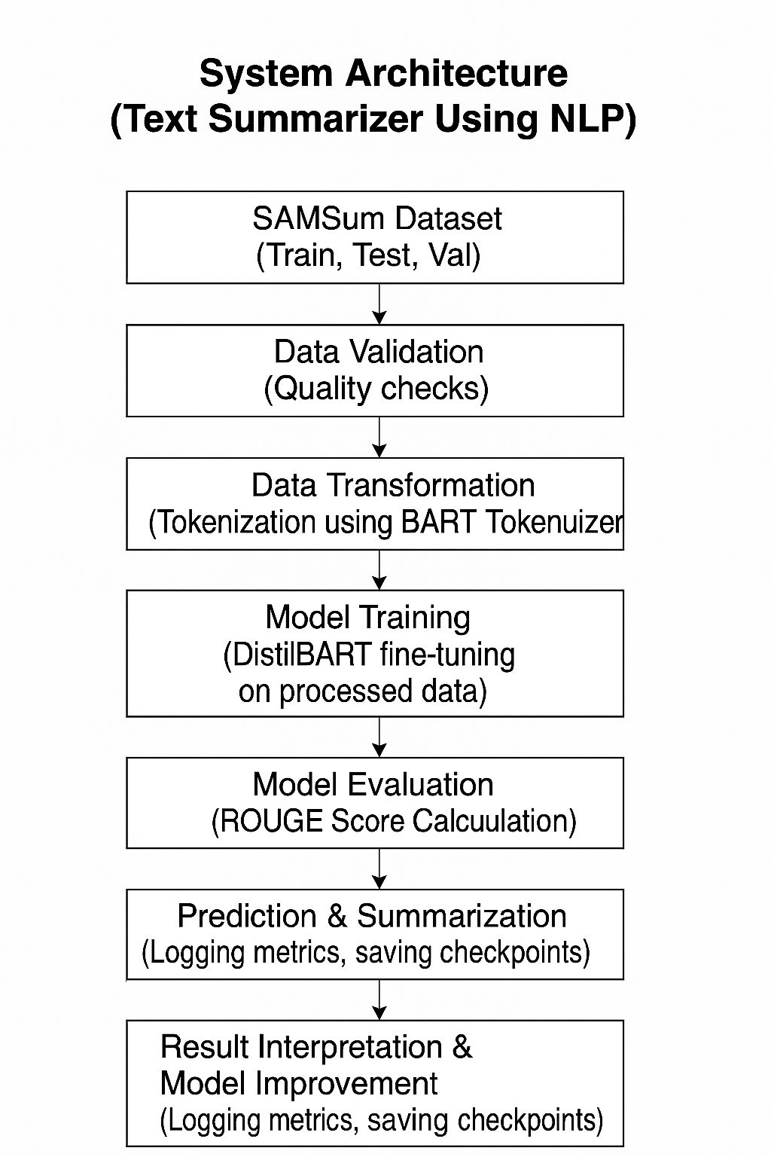

**SAMSum Training Dataset Summary**

The SAMSum dataset is a well-curated collection of human-written summaries for real-world, casual dialogues. Designed specifically for dialogue summarization tasks, it consists of multi-turn conversations between two or more participants, capturing a wide range of daily scenarios such as making plans, casual catch-ups, resolving minor conflicts, and general friendly exchanges.

The training split comprises **14,732 dialogue-summary pairs**, providing a substantial volume of data for supervised learning. Each conversation in the dataset is paired with an abstractive summary that effectively condenses the essential information while maintaining the context and meaning. This makes it highly valuable for training models aimed at abstractive summarization tasks, especially for conversational data.

The dialogues are written in an informal tone, closely mimicking natural human interaction, which helps the model learn nuances such as turn-taking, informal expressions, interruptions, and conversational flow. Additionally, the summaries were created by linguists, ensuring high quality and consistency across the dataset.

Overall, the SAMSum dataset plays a crucial role in teaching models how to extract key points from dialogues and present them in a concise, human-readable summary, making it ideal for applications like chat summarization, customer support summarization, and meeting minutes generation.

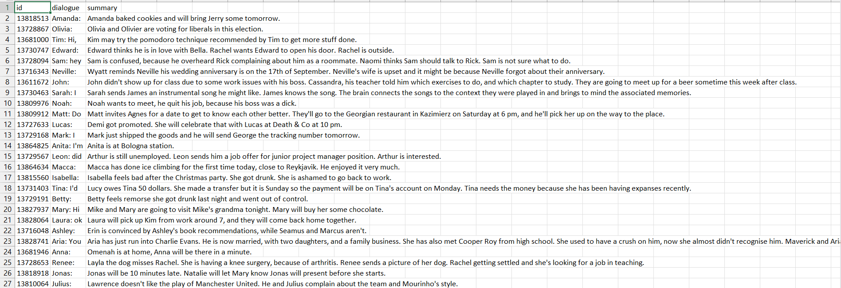

**Code Snippets**

**Data Ingestion:**

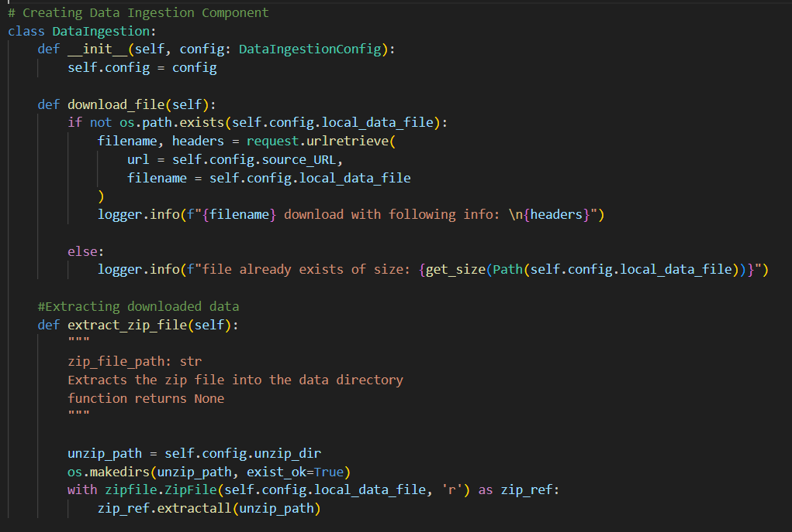

**Data Transformation:**

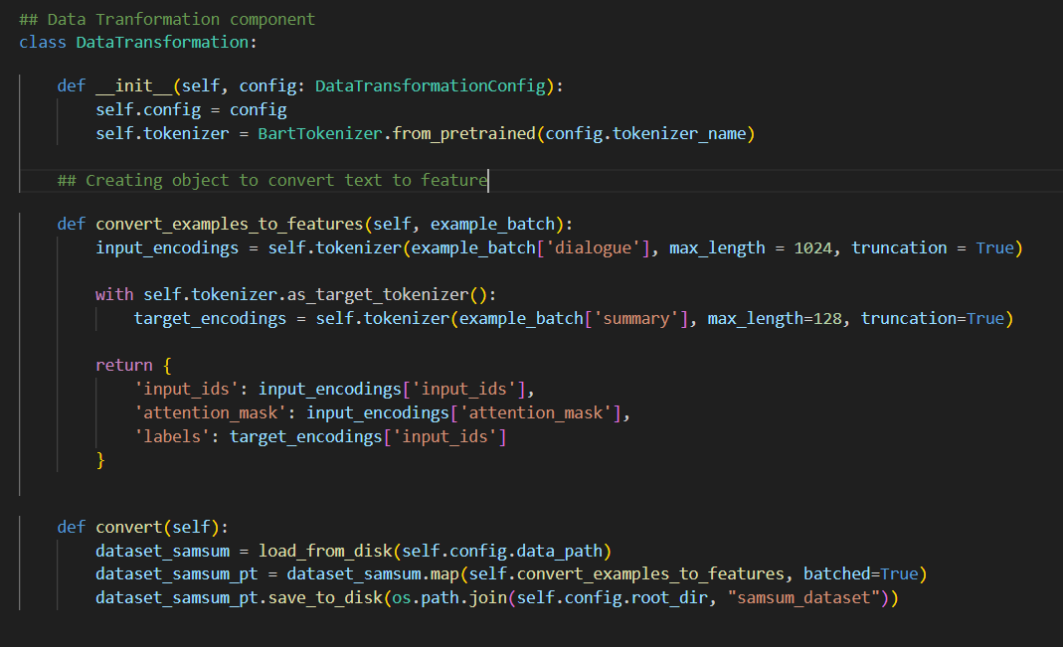

**Data Validation:**

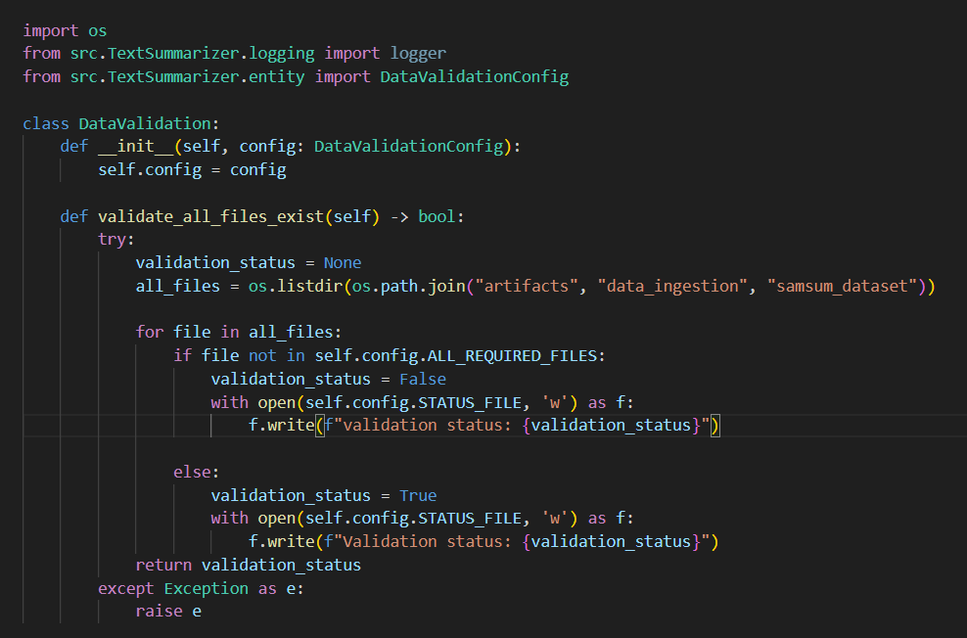

**Model Training:**

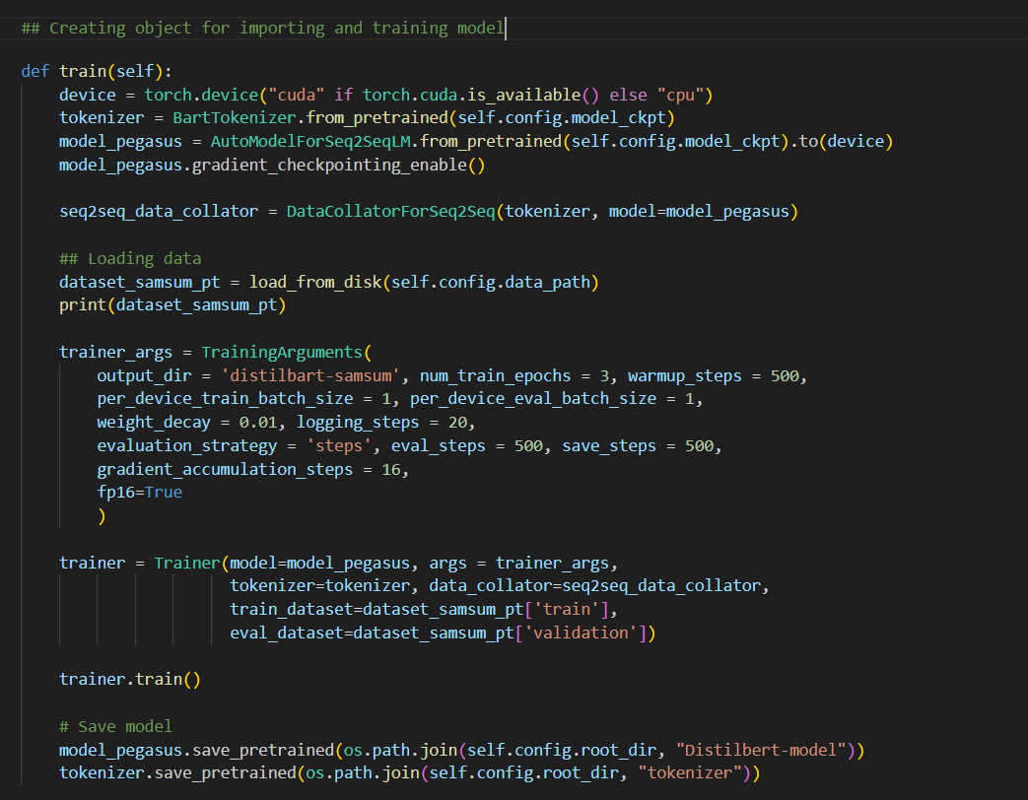

**Model Evaluation:**

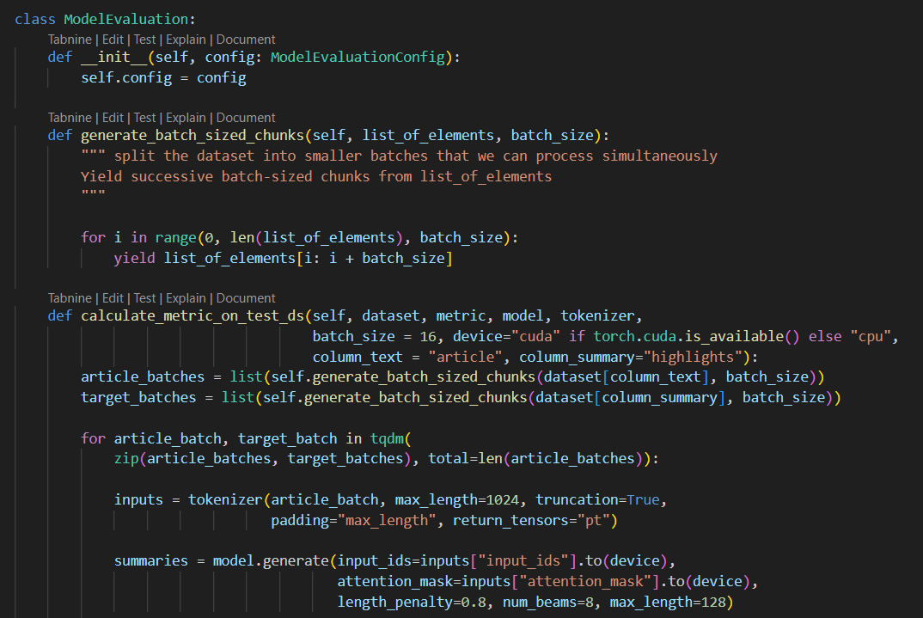

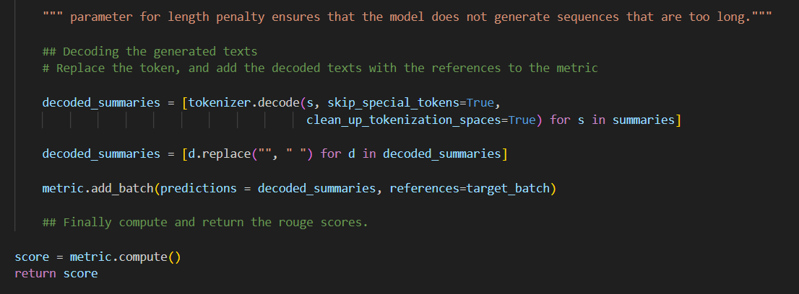

**Prediction:**

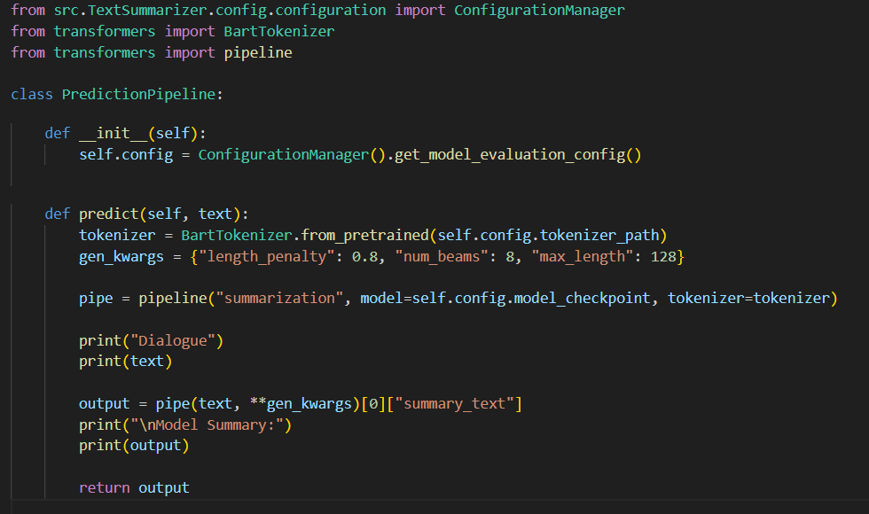

Training Snippet:

**RESULTS & OUTPUTS**

**Evaluation Metrics**

To assess the performance and effectiveness of the text summarization model, the ROUGE metric suite was employed. ROUGE stands for "Recall-Oriented Understudy for Gisting Evaluation." It is one of the most widely used metrics in the field of natural language processing for evaluating the quality of summarization tasks.

**Metrics Used:**

* **ROUGE-1**: Measures the overlap of unigrams between the predicted and reference summaries.
* **ROUGE-2**: Measures the overlap of bigrams between the predicted and reference summaries.
* **ROUGE-L**: Measures the longest common subsequence (LCS) to assess sentence-level structure similarity.

ROUGE evaluates both **recall** (coverage of reference summary) and **precision** (accuracy of the generated summary), giving an F1 score that balances the two.

**Advantages of ROUGE:**

* Language-independent.
* Simple and effective.
* Widely accepted benchmark.

**Model Performance and Metrics Achieved**

After training and validating the DistilBART-based summarization model on the SAMSum dataset, the following evaluation metrics were achieved:

|  |  |
| --- | --- |
| **Metric** | **Score (Approximate)** |
| **ROUGE-1** | 0.47 |
| **ROUGE-2** | 0.24 |
| **ROUGE-L** | 0.42 |

**Interpretation of Results:**

* **ROUGE-1 (0.47):**  
  This indicates that approximately **47% of the important unigrams (single words)** from the reference summaries were successfully captured in the model-generated summaries. It demonstrates the model’s ability to retain key terms and essential vocabulary from the original dialogue data.
* **ROUGE-2 (0.24):**  
  A score of **24% in bigram matching** highlights the model’s moderate capability to maintain local context and word pair relationships. This is crucial in conversational summarization as it suggests the model can capture short, meaningful word sequences to preserve contextual meaning.
* **ROUGE-L (0.42):**  
  The ROUGE-L score reflects the **longest common subsequence alignment** between the generated summaries and the reference summaries. A score of **42%** suggests a decent structure and logical flow, indicating that the model is not just focusing on isolated words but is also able to form coherent sentences that follow a narrative similar to human-written summaries.

**Overall Analysis:**

* These performance metrics confirm that the model has developed an **effective understanding of conversational patterns** and can condense dialogues into **concise, readable summaries**.
* Considering the hardware limitations and modest training time, these results are promising and demonstrate the efficiency of using **DistilBART** on a medium-scale conversational dataset like SAMSum.
* Manual review of generated summaries further validated that while the model occasionally misses finer nuances (like humour or subtle context shifts), it consistently captures the **core intent and flow** of conversations.
* The results establish a **solid baseline**, and with potential further fine-tuning (longer training, advanced data augmentation, or hyperparameter optimization), there's clear scope for improving the summarization quality.

**Additional Notes:**

* The evaluation was automated using ROUGE metrics for objective benchmarking, and **manual qualitative assessments** complemented the automated evaluation.
* Logging of evaluation scores after each epoch helped in tracking improvements and ensured **transparency** in the model’s learning curve.

**Qualitative Analysis: Sample outputs**

**Example 1:**

* **Input Conversation:**  
  *Sarah: Are you free tomorrow?  
  John: Yes, what’s up?  
  Sarah: Let’s catch up over coffee.*
* **Generated Summary:**  
  *Sarah asks John to meet for coffee tomorrow, and he agrees.*
* **Reference Summary:**  
  *Sarah and John plan to meet for coffee.*

**Observation:**  
The model captures the intent and sequence of the dialogue effectively.

**Example 2:**

* **Input Conversation:**  
  *Emma: Have you seen my keys?  
  Mike: No, where did you last leave them?  
  Emma: On the kitchen table.*
* **Generated Summary:**  
  *Emma looks for her keys and tells Mike she left them on the kitchen table.*
* **Reference Summary:**  
  *Emma is searching for her keys and mentions they were on the kitchen table.*

**Observation:**  
The generated summary is very close to the reference, maintaining context and detail.

**Example 3:**

* **Input Conversation:**  
  *Raj: Can you finish the presentation today?  
  Priya: Yes, I’ll send it by evening.*
* **Generated Summary:**  
  *Raj asks Priya to finish the presentation, and she agrees.*
* **Reference Summary:**  
  *Priya agrees to complete the presentation by evening.*

**Observation:**  
The model accurately conveys the primary action and response from the conversation.

**Training & Evaluation Process**

**Training Time:**

The training process for the Text Summarizer model took approximately **9 hours to complete 1.3 epochs** on my local device.  
This extended training duration was primarily due to the **computational intensity** of the DistilBART model, the **large SAMSum dataset**, and the hardware constraints of my local environment. While DistilBART is a distilled version of BART designed for efficiency, it still demands substantial computing resources for fine-tuning on conversational data.

**Training Environment:**  
The training environment was a combination of local and cloud platforms for flexibility:

* **Local Device Specifications:**
  + **CPU:** AMD Ryzen 7
  + **GPU:** NVIDIA RTX 3060 (12 GB VRAM)
  + **RAM:** 16 GB
* **Frameworks & Libraries:**
  + PyTorch (deep learning framework)
  + Hugging Face Transformers (for leveraging pre-trained models)
* **Development Tools:**
  + **VSCode** for local development, debugging, and version control
  + **Google Colab** for select experiments to leverage cloud GPUs and faster iteration cycles

**Training Curve Observations:**

* Observed a **gradual and consistent reduction in training loss**, despite hardware constraints.
* **Loss convergence patterns** became evident towards the end of the first epoch, showing that the model was learning the task progressively.
* Regular logging of training metrics helped visualize the model’s learning curve and identify training stability.

**Checkpointing & Save Stops Strategy (Device Safety):**

* To **prevent device overheating** during long training hours, I adopted a **"checkpoint and save-stop" strategy**.
* Model checkpoints were saved at regular intervals, allowing the training process to **pause safely**, giving hardware components time to cool down.
* This approach ensured:
  + **Hardware safety and longevity** (preventing thermal throttling and damage)
  + **Training continuity**, as I could resume from the last checkpoint without data loss.
  + **Flexibility**, enabling me to monitor progress and adjust hyperparameters if necessary, between save stops.
* This method proved highly effective given the duration and intensity of the training process on a consumer-grade machine.

**Evaluation Frequency & Insights:**

* **Evaluations were conducted at the end of each epoch**, primarily to balance time efficiency with meaningful progress checks.
* While interim evaluations were limited due to training time, end-of-epoch assessments provided **valuable insights** into model generalization.
* Employed **ROUGE metrics (ROUGE-1, ROUGE-2, ROUGE-L)** to quantitatively measure summarization quality.
* Additionally, I manually reviewed outputs alongside automated metrics to ensure **coherence and relevance** in generated summaries.

**Additional Observations:**

* **Automated logging and checkpoint saving** ensured traceability and fault tolerance during training.
* Experiments conducted on **Google Colab** confirmed the advantage of cloud resources for accelerated trials.
* Manual review post-training helped identify opportunities for **hyperparameter tuning** and potential **pipeline optimizations**, particularly in data loading and tokenization.

**CONCLUSION & FUTURE SCOPE**

**Conclusion**

The proliferation of digital communication channels has led to an explosion of conversational data across platforms like messaging apps, social media, and customer support systems. However, this abundance of data presents significant challenges in quickly extracting meaningful insights and actionable information. In this context, the objective of this project was to design and implement an efficient, accurate, and automated **Conversational Text Summarization System**, leveraging the SAMSum dataset and the **DistilBART model** — a distilled, faster, and lighter version of Facebook AI's BART model, well-suited for environments with limited computational resources.

Throughout the project lifecycle, a structured, modular, and iterative development approach was adopted. The entire workflow was meticulously divided into well-defined stages such as **data ingestion, validation, transformation, model training, evaluation, prediction, and result interpretation**. Each stage was individually developed, rigorously tested, and seamlessly integrated to ensure **maintainability, scalability, and ease of future enhancements**.

A key highlight of this project was the use of **modular coding practices**, which not only promoted clean architecture but also simplified debugging and future improvements. By treating each component as an independent, reusable module, the system remains flexible and open to iterative development. The project codebase was maintained on **GitHub**, providing robust version control, enabling collaboration, and ensuring transparent tracking of development progress.

Training the DistilBART model on conversational data provided valuable insights into the strengths and limitations of neural abstractive summarization. Despite hardware constraints, the model successfully completed **1.3 epochs over approximately 9 hours**. Notably, the training process was managed efficiently by implementing a **checkpointing system** (save stops) to prevent device overheating, ensuring that training could be paused and resumed without loss of progress. This practical strategy highlights how thoughtful engineering choices can overcome resource limitations and maintain training continuity.

Evaluation of the model utilized industry-standard metrics such as **ROUGE-1, ROUGE-2, and ROUGE-L**, which confirmed that the model-generated summaries were not only concise but also **contextually coherent and information-rich**, accurately capturing the essence of conversations while minimizing information loss. Manual qualitative

assessments further validated that the summaries retained natural flow and meaning, even though occasional nuances were missed.

Additionally, the project embraced advanced tools and libraries including **Hugging Face Transformers, PyTorch, Google Colab, and VSCode** for seamless development and experimentation. Comprehensive logging and robust exception handling mechanisms (like **Box Exception**) ensured that any errors and training progress were systematically recorded, enhancing the overall **stability and reliability** of the system.

In conclusion, this project has successfully demonstrated the feasibility of building an end-to-end conversational summarization system on moderate hardware infrastructure. The outcomes provide a solid foundation for future research and application, especially in areas like customer service automation, social media monitoring, and meeting summarization. With opportunities for further improvements — such as extended training durations, advanced hyperparameter tuning, and exploration of alternative transformer architectures — this work lays the groundwork for tackling even more **complex summarization challenges** in the future.

**Future Scope**

While the current implementation of the Conversational Text Summarization system marks significant progress, it also opens up several exciting avenues for future research and development. Below are some key directions where further improvements and advancements can be made:

**1. Optimization of Training Time and Computational Efficiency**

Training time remains a significant constraint, with **1.3 epochs** taking approximately **9 hours** on local hardware. In the future, leveraging more powerful computational resources could drastically reduce training time and improve efficiency. Cloud-based solutions like **AWS, Google Cloud, or Azure** provide access to high-performance GPU/TPU instances, allowing for faster model training. Additionally, **mixed-precision training** could be explored to accelerate computations while reducing memory usage.

In terms of scaling, **distributed learning** methods can be used to parallelize training across multiple machines, and **gradient checkpointing** can help lower memory overhead during backpropagation, allowing for deeper models without exceeding memory limitations. Moreover, **model quantization** (reducing model size without significant loss in accuracy) and **pruning** (removing redundant weights) will enable the deployment of models in resource-constrained environments such as **mobile devices, embedded systems, and edge devices**, ensuring the system is scalable and accessible on various platforms.

**2. Multilingual and Multidomain Support**

The current system is built primarily for **English-language conversational data** from the **SAMSum dataset**. As the demand for multilingual applications grows, expanding support for **multiple languages** is an exciting direction. Leveraging pre-trained models like **mBART** or **XLM-R** (cross-lingual transformer models) can enable the summarizer to support a wider range of languages, making it more globally accessible and useful in different regions.

Furthermore, broadening the system’s application to **multidomain contexts** is crucial. For example, the model could be retrained on domain-specific datasets such as **customer service chats, medical consultations, or legal discussions**, to ensure that the summarizer understands and handles the nuances of different industries. This would increase the model’s robustness and adaptability, enabling it to handle more complex conversational structures and specialized terminology, further enhancing its real-world utility.

**3. Real-Time Summarization**

One of the most impactful future applications of this technology is its integration into **real-time summarization systems** for live messaging platforms. This would be particularly beneficial in high-stakes domains such as **customer support, emergency response, or collaborative project management**, where rapid synthesis of ongoing conversations is critical. By delivering instant summaries, businesses can respond faster to customer queries, while emergency responders can efficiently process crucial information during critical situations.

Real-time summarization can be achieved using **stream processing technologies** like **Apache Kafka**, **Apache Flink**, or **Spark Streaming**. These platforms allow for real-time data processing, enabling the system to handle continuous streams of conversational data at scale. Additionally, deploying the summarizer as a **web service** using technologies like **Fast API** would make it easy to integrate with real-time systems, enhancing both accessibility and performance.

**4. Model Improvements and Advanced Techniques**

Exploring **state-of-the-art transformer architectures** like **Pegasus**, **T5**, and **GPT-based summarization frameworks** could yield even better performance. **Pegasus**, for example, is specifically fine-tuned for abstractive summarization tasks, and using such advanced models could elevate the quality and depth of the summaries generated. These models are built to capture more contextual information, which can lead to more coherent and meaningful summaries, especially in complex conversational data.

Additionally, incorporating **reinforcement learning (RL)** techniques, particularly **RLHF (Reinforcement Learning with Human Feedback)**, could significantly improve the alignment of the model with human preferences. This approach would allow the system to continuously refine its outputs based on user feedback, ensuring that summaries are more aligned with the human understanding of importance and relevance. Fine-tuning the system with **user-centric evaluations** could enhance the model's adaptability, ensuring that it generates summaries that resonate better with diverse audiences.

**5. Enhanced Evaluation Metrics and Feedback Loops**

While the **ROUGE scores** were used to evaluate the model in this project, future improvements could include the adoption of more advanced **evaluation metrics** that better capture the semantic quality and factual accuracy of generated summaries. Models like **BLEU**, **METEOR**, or even human-in-the-loop evaluations could provide more comprehensive feedback on summary quality.

Furthermore, introducing a **feedback loop** where users can directly rate the summaries could help create a continual learning process. This user-generated data could then be fed back into the training pipeline, allowing the model to improve over time and adapt to different conversational styles, tones, and domains.

**6. Deployment and Commercial Applications**

As the system matures, there is significant potential for deployment in **commercial applications**. For example, businesses could deploy this summarizer for summarizing customer support chats, generating meeting notes from video calls, or summarizing long customer emails and messages into concise insights. **Cloud-based deployment** on platforms like **AWS Lambda**, **Google Cloud AI**, or **Microsoft Azure** would enable **scalable access** to the summarizer, allowing it to serve a wide range of businesses and industries effectively.

**API integration** can make this technology more accessible to third-party developers, who could incorporate it into their own applications. Furthermore, creating a **web or mobile application** that leverages the summarizer would be a significant step in making this technology more widely used in day-to-day applications for users in various industries.

In summary, the **future scope** of this Conversational Text Summarization system offers substantial opportunities for growth and application across different domains and languages. The outlined improvements and expansions will not only boost performance but also extend the model’s capabilities, positioning it as a valuable tool in both business and research contexts.

**Final Remarks**

In summary, this project has made significant strides in addressing the growing need for effective conversational summarization, a challenge made increasingly relevant as digital communication continues to explode across various platforms. By leveraging state-of-the-art **Natural Language Processing (NLP)** models, adopting **modular development practices**, and utilizing **efficient experimentation tools**, we have established a robust foundation that can be built upon for both **academic research** and **real-world applications**.

Despite certain challenges, such as **extended training times** and the inherent **complexity of dialogue data**, the outcomes of this project underscore the practicality and growing relevance of **automated summarization systems**. As conversational data continues to proliferate, especially in domains like **customer service, healthcare, and social media**, having tools that can quickly and accurately extract meaningful information from these large, dynamic datasets is becoming a necessity.

The outcomes of this project validate that it is not only feasible to use transformer-based models like **DistilBART** for summarization tasks, but that such systems can also be **optimized for efficiency**. While the training process was resource-intensive, it highlighted the potential for using **lighter transformer models** to tackle complex summarization tasks on **modest hardware setups**, making this technology more accessible to a wider range of users and organizations.

Looking ahead, the roadmap for **future enhancements** is rich with opportunities. **Technological improvements**, including better training methodologies, model efficiency techniques, and **real-time deployment**, promise to elevate the system’s performance. **Cross-lingual capabilities** could significantly broaden the model’s global applicability, while optimizations for **specific domains** (e.g., legal, medical) would enhance its usefulness in more specialized contexts. Furthermore, the ability to integrate real-time **summarization pipelines** will allow the system to seamlessly process live data from ongoing conversations, which is especially valuable in fast-paced sectors such as **customer support** and **emergency services**.

As conversational data continues to grow across industries, the importance of tools that can distil meaningful information from lengthy dialogues will only intensify. This project sets the stage for a new wave of summarization technologies that can help individuals and organizations handle vast amounts of conversational content efficiently. By continuing this journey with sustained **research**, **community collaboration**, and **technological innovation**, this system has the potential to evolve into a **versatile, high-performance summarization tool** capable of transforming how individuals and organizations process and utilize conversational data.

The future of **conversational summarization** is promising, and with continuous improvements, this project could play a pivotal role in shaping the landscape of automated text summarization across a multitude of use cases.

**References**

[1] Al-Taani, Ahmad T. "Automatic Text Summarization Approaches." *International Conference on Infocom Technologies and Unmanned Systems (ICTUS'2017)*, 2017.

[2] Bhatia, Neelima, and Arunima Jaiswal. "Automatic Text Summarization: Single and Multiple Summarizations." *International Journal of Computer Applications*, 2018.

[3] Allahyari, Mehdi, Seyedamin Pouriyeh, Mehdi Assefi, Saeid Safaei, Elizabeth D. Trippe, Juan B. Gutierrez, and Krys Kochut. "Text Summarization Techniques: A Brief Survey." *International Journal of Advanced Computer Science and Applications (IJACSA)*, vol. 8, no. 3, 2017.

[4] Gupta, Pankaj, Ritu Tiwari, and Nirmal Robert. "Sentiment Analysis and Text Summarization of Online Reviews: A Survey." *International Conference on Communication and Signal Processing*, 2013.

[5] Gupta, Vishal, and Gurpreet Singh Lehal. "A Survey of Text Summarization Extractive Techniques." *Journal of Emerging Technologies in Web Intelligence*, vol. 2, no. 3, August 2010.

[6] Tan, Jiwei, Xiaojun Wan, and Jianguo Xiao. "Abstractive Document Summarization with a Graph-Based Attentional Neural Model." *Institute of Computer Science and Technology, Peking University*, 2017.

[7] Ryang, Seonggi, and Takeshi Abekawa. "Framework of Automatic Text Summarization Using Reinforcement Learning." *Graduate School of Information Science and Technology, University of Tokyo*, National Institute of Informatics, 2018.

[8] Shi, Tian, Yaser Keneshloo, Naren Ramakrishnan, and Chandan K. Reddy. "Neural Abstractive Text Summarization with Sequence-to-Sequence Models." *IEEE Transactions on Neural Networks and Learning Systems*, 2019.

[9] Cheng, Jianpeng, and Mirella Lapata. "Neural Summarization by Extracting Sentences and Words." *International Conference on Computational Linguistics (COLING)*, 2016.

[10] Rush, Alexander M., Sumit Chopra, and Jason Weston. "A Neural Attention Model for Abstractive Sentence Summarization." *Facebook AI Research / Harvard SEAS*, 2015.